Dashboard and Story Visualization

Date | 7 July 2026
Team ID | SWTID-20264431
Project Name | Strategic Product Placement Analysis

- Dashboard :

Figure 1: Interactive Tableau Dashboard

The interactive Tableau dashboard provides comprehensive retail sales analysis through multiple visualizations, interactive filters, and calculated fields, enabling effective business decision-making.
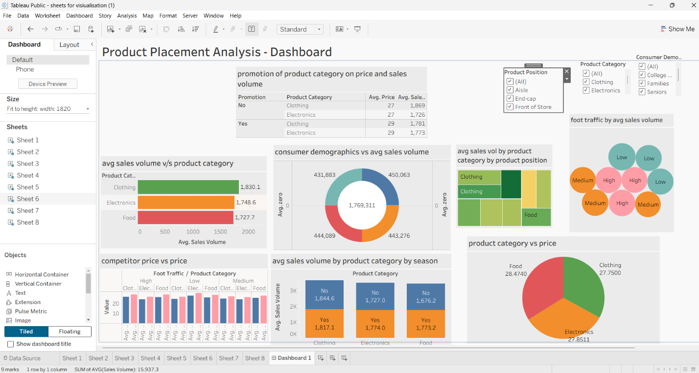
Link :
The dashboard consists of the following visualizations:
- Average Sales Volume vs Product Category (Horizontal Bar Chart) – compares average sales volume across different product categories.
- Promotion of Product Category on Price and Sales Volume (Text Table) – analyzes the impact of promotional activities on product price and sales volume.
- Consumer Demographics vs Average Sales Volume (Donut Chart) – represents sales contribution from different customer demographic groups.
- Average Sales Volume by Product Category and Product Position (Tree Map) – evaluates product placement effectiveness across various store locations.
- Foot Traffic by Average Sales Volume (Packed Bubble Chart) – illustrates the relationship between customer foot traffic and average sales volume.
- Competitor Price vs Product Price (Clustered Bar Chart) – compares product prices with competitor pricing across categories.
- Average Sales Volume by Product Category by Season (Stacked Bar Chart) – highlights seasonal variations in sales performance.
- Product Category vs Price (Pie Chart) – presents the average price distribution among product categories.
Overall, the dashboard provides a comprehensive view of retail performance and supports business users in identifying high-performing product categories, evaluating promotional effectiveness, optimizing product placement strategies, monitoring competitor pricing, and making informed, data-driven decisions.

- Tableau Story :

Figure 2: Story point 1- Product category performance

This story presents the sales performance of different product categories and highlights the highest-performing product categories based on average sales volume.

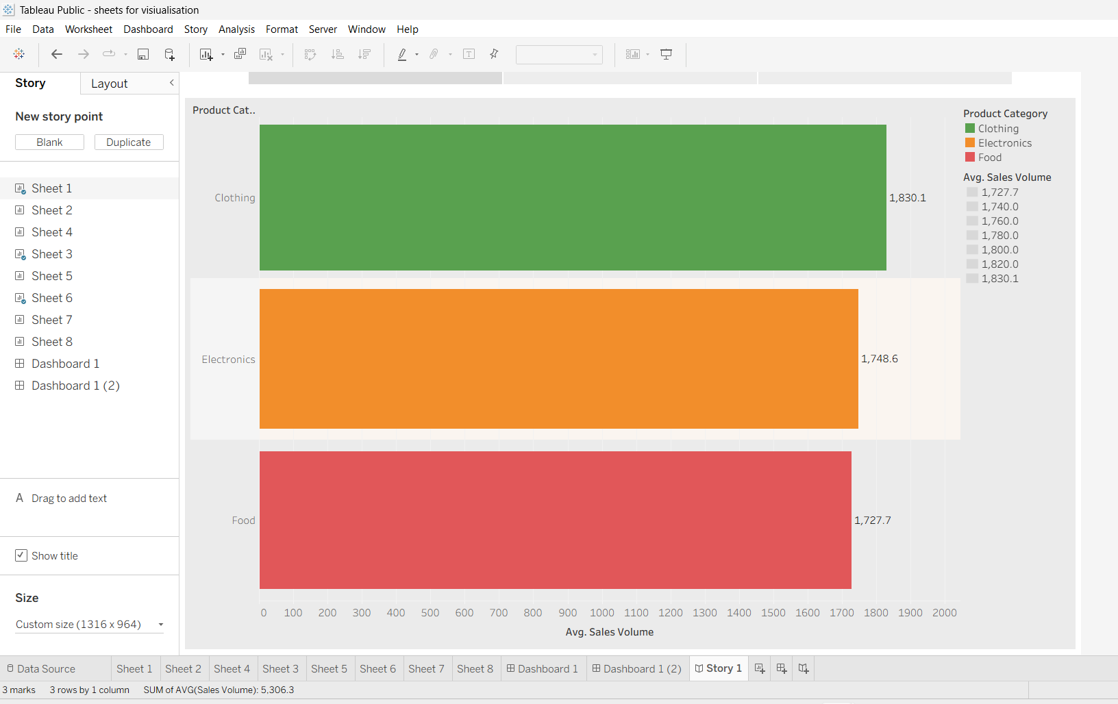

Figure 3: Story Point 2- Product position and foot traffic analysis

This story analyzes the relationship between product placement, customer foot traffic, and sales performance to support product placement decisions.

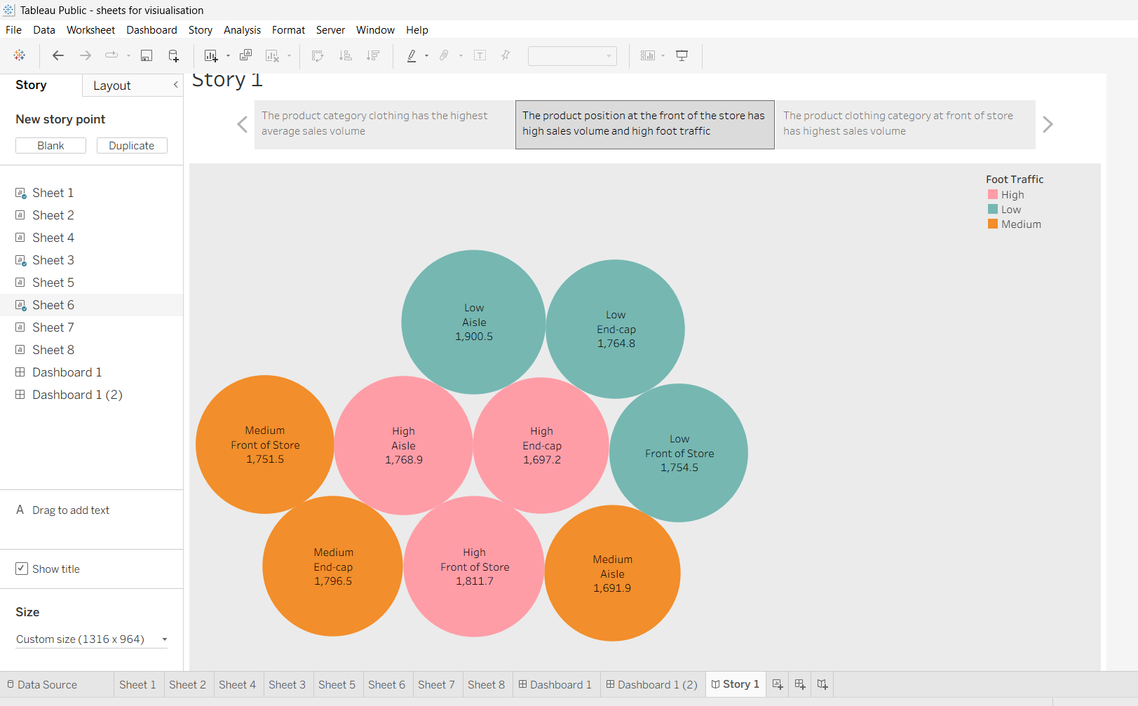

Figure 4: Story Point 3 – Product Position by Category
This story illustrates how different product positions influence the sales performance of various product categories.
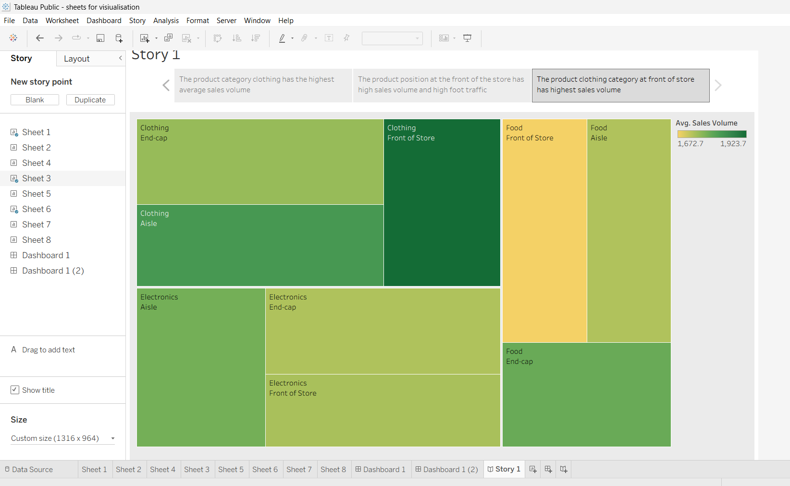
Result :
From the dashboard analysis, the following key business insights were identified:
- Clothing recorded the highest average sales volume compared to Electronics and Food products.
- Promotional products showed a slight increase in average sales volume, indicating that promotional campaigns positively influence customer purchasing behavior.
- Consumer demographic analysis revealed relatively balanced sales contributions across College Students, Families, and Seniors.
- Products placed in Front of Store and End-cap locations demonstrated better sales performance than products placed in regular aisles.
- Higher customer foot traffic generally resulted in higher sales volume, confirming the importance of effective product placement.
- Competitor pricing remained close to product pricing, suggesting a competitive retail pricing strategy.
- Seasonal analysis indicated variations in average sales volume, helping identify periods of stronger customer demand.
- Product price distribution across categories remained relatively consistent, with Food products having slightly higher average pricing than Clothing and Electronics.

Tableau Public Link :
https://public.tableau.com/app/profile/rohit.jangid8403/viz/sheetsforvisiualisation/Dashboard1?publish=yes
https://public.tableau.com/app/profile/rohit.jangid8403/viz/sheetsforvisiualisationnewcalc/Story1?publish=yes
https://public.tableau.com/app/profile/rohit.jangid8403/viz/sheetsforvisiualisation/Dashboard1?publish=yes

